 Activities By: Kelly Inouye-Kwaak RT Unit: N3 Roosevelt Care Center 118 Parsonage Road Edison, NJ 08837
2026

Sunday | Monday | Tuesday | Wednesday | Thursday |  | Friday |  | Saturday
Pet Therapy as Announced  Coffee Shop: 8:30am-3:00pm  Business Office: M-F 10:00am-3:00pm  Weekends 10:00am-12:00pm  Beauty Parlor - By Appointment  1:1 Sensory and Room Daily  April Birthday Celebration: 4/23/26  Wednesdays Bingo 5:45pm N4  Thursdays Pokeno 5:45pm N4  Activities are Subject to Change** |  |  | 1  9:30 Morning Brew  10:30 April Hangman  2:00 Rosary and Communion N4  2:00 Easter Bonnets  5:45 For Fun Bingo N4 | 2 Passover  9:30 Morning Brew  10:30 Making Easter Baskets  2:00 BINGO  5:45 Pokeno N4  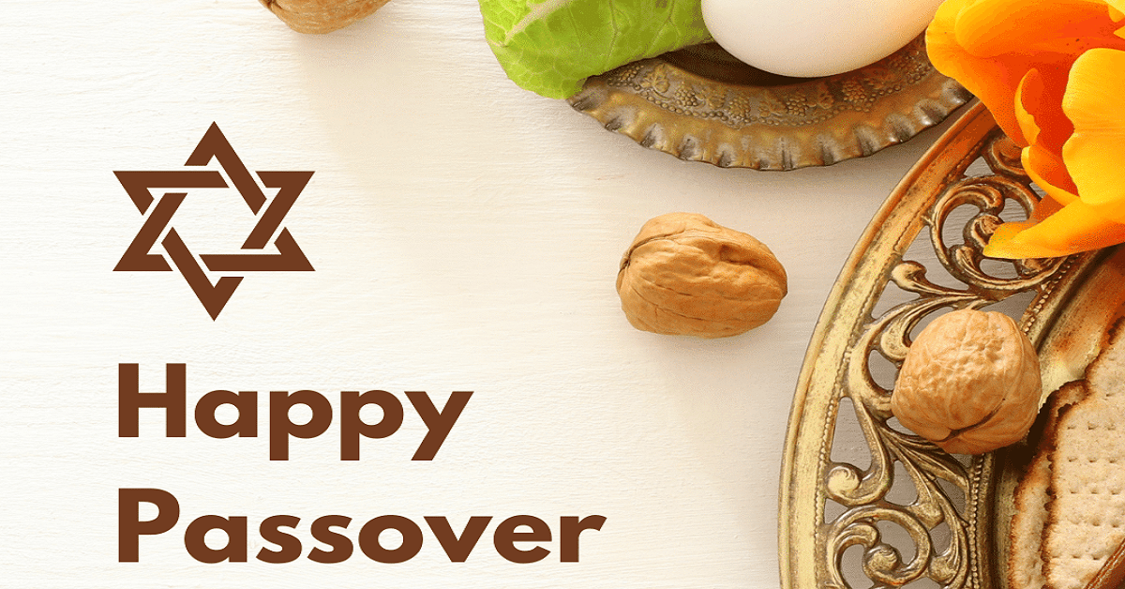 |  | 3 Good Friday  9:30 Morning Brew  10:30 Fancy Friday Nails  2:00 Dyeing Eggs N4   |  | 4  AM Coffee Cart  11:00 1:1 Room Visits  2:00 First Baptist Church of Metuchen N4
5  AM Coffee Cart  11:00-12:00pm Easter  Bunny Visits  2:00 Vansh on the Violin N4   | 6  9:30 Morning Brew  10:30 Name Three-Spring Edition  10:30 “Between the Lines” Book Club N2  2:00 Story Telling with Queen Nur N4 | 7  9:30 Morning Brew  10:30 Board Games    10:30 Pet Therapy w/Riley N4  2:00 BINGO | 8  9:30 Morning Brew  10:30 Yahtzee  10:45 Teddy Visits  2:00 Catholic Mass Services N4  2:00 Flower Power  5:45 For Fun Bingo N4 | 9  9:30 Morning Brew  10:30 Crafters Delight  2:00 BINGO    5:45 POKENO N4 | 10  9:30 Morning Brew  10:30 Pet Therapy w/Quinn N4    2:00 Joe Caristo Entertains N4 |  | 11  AM Coffee Cart  11:00 1:1 Room Visits  2:00 BINGO N4
12  AM Coffee Cart  11:00 1:1 Room Visits  2:00 POKENO N4 | 13  9:30 Morning Brew  10:30 Uno  10:30 “Between the Lines” Book Club N2  2:00 Angela Escanillas Entertains N4 | 14  9:30 Morning Brew  10:30 Puzzles Challenge  10:30 Food Committee Mtg N4  2:00 BINGO | 15  9:30 Morning Brew 10:30 Snakes and Ladders  2:00 Rosary and Communion N4  2:00 Olive Garden Order Out (Must Sign Up) N4  5:45 For Fun Bingo N4   | 16  9:30 Morning Brew  10:30 Jewelry Making  2:00 BINGO  5:45 POKENO N4  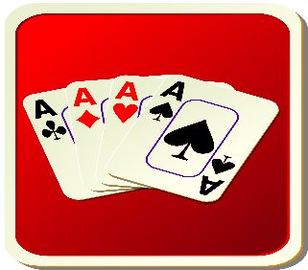 |  | 17  9:30 Morning Brew  10:30 Friday Manicures  2:00 Spring Wreaths   |  | 18  AM Coffee Cart  11:00 1:1 Room Visits  2:00 BINGO N4
19  AM Coffee Cart  11:00 1:1 Room Visits  2:00 Vansh on the Violin N4 | 20  9:30 Morning Brew  10:30 Resident’s Choice  10:30 “Between the Lines” Book Club N2  2:00 Let’s Make Paninis  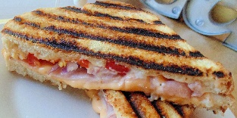 | 21  9:30 Morning Brew    10:30 Battle of the Brains  2:00 BINGO | 22  9:30 Morning Brew  10:30 Spring Flower Beads  2:00 Catholic Mass N4  2:00 Earth Day Activity    5:45 BINGO N4 | 23  9:30 Morning Brew  10:30 Dominoes  2:00 Bingo  5:45 Pokeno N4 |  | 24  9:30 Morning Brew  10:30 Left, Right, Center  10:30 Pet Therapy w/Quinn N4  2:00 Fairy Gardens  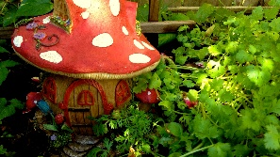 |  | 25  AM Coffee Cart  11:00 1:1 Room Visits  2:00 POKENO N4
26  AM Coffee Cart  11:00 1:1 Room Visits  2:00 JP Stevens Musical Performance N4 | 27  9:30 Morning Brew  10:30 Canvas Art  10:30 “Between the Lines” Book Club N2  2:00 St. Lukes Religious Services N4  2:00 Jello Delight | 28  9:30 Morning Brew  10:30 Denim Crafts    10:30 Pet Therapy w/Riley N4  2:00 BINGO | 29  9:30 Morning Brew  10:30 Denim Crafts II  2:00 Rosary and Communion Services N4  2:00 Patio Time (Weather Permitting)  5:45 BINGO N4 | 30  9:30 Morning Brew  10:30 May Day Baskets  1:15 Resident Council Mtg N4  2:00 Bingo  5:45 Pokeno N4 |  | 

