May 2026
Sunday | Monday |  | Tuesday |  | Wednesday | Thursday | Friday |  | Saturday
Activities by: Neema Sheth, RT Unit: N4 Roosevelt Care Center 118 Parsonage Road, Edison NJ 08837
Pet Therapy with Ellie, Riley, Chase, Gus and Teddy as Announced  Coffee Shop: 8:30am-3:00pm  Business Office: M-F 10:00am-3:00pm Sat & Sun 10:00am-12:00pm Beauty Parlor - By Appointment  1:1 Sensory and Room Visits Daily  May Birthday Celebration 5 / 21 /26  Dining room music throughout the day!  ***All Activities Are Subject to Change**  Between the Lines Book Club- 10:30 Mondays (N2) |  |  |  |  |  |  | 1  9:30 Morning Check-In/Coffee Cart  10:30 Activity Planning Meeting  10:30 Cardio Classics  1:00 Music on Alexa!  2:00 A Day at the Races: Kentucky Derby Party   |  | 2  10:00 Morning Coffee  11:00 1:1 Room Visits  2:00 First Baptist Church Service
3  A.M Coffee Cart  11:00 1:1 Room Visits  2:00 Pokeno | 4  9:30 Meet & Greet/Coffee Cart  10:15 In the News  10:30 LRC Game  1:00 Soul Music  2:00 Jewelry Making |  | 5  9:30 Meet & Greet/Coffee Cart  10:15 Card Sharks  10:30 Seatwork Exercise  1:00 Elvis Music  2:00 Cinco De Mayo Fiesta Party   |  | 6  9:30 Meet & Greet/Coffee Cart  10:15 Horoscopes  10:30 Pet Therapy w. Riley  1:00 Religious Hymns  2:00 Rosary & Communion Services  2:15 Mother’s Day Crafts  5:45 Bingo | 7  9:30 Morning Check-In/ Coffee Cart  10:15 Table Volleyball  10:30 Exercise  1:00 70’s Music  2:00 Bingo  5:45 Pokeno   | 8  9:30 Morning Check-In/Coffee Cart  10:15 Baseball Toss  10:30 Metro Workout  1:00 Music on Alexa!  2:00 Mother’s Day Social   |  | 9  10:00 Morning Coffee  11:00 1:1 Room Visits  2:00 First Baptist Church Special Mother’s Day Service
10  A.M Coffee Cart  11:00 1:1 Room Visits  2:00 Creating Memories w/Mom (Scrapbooking)  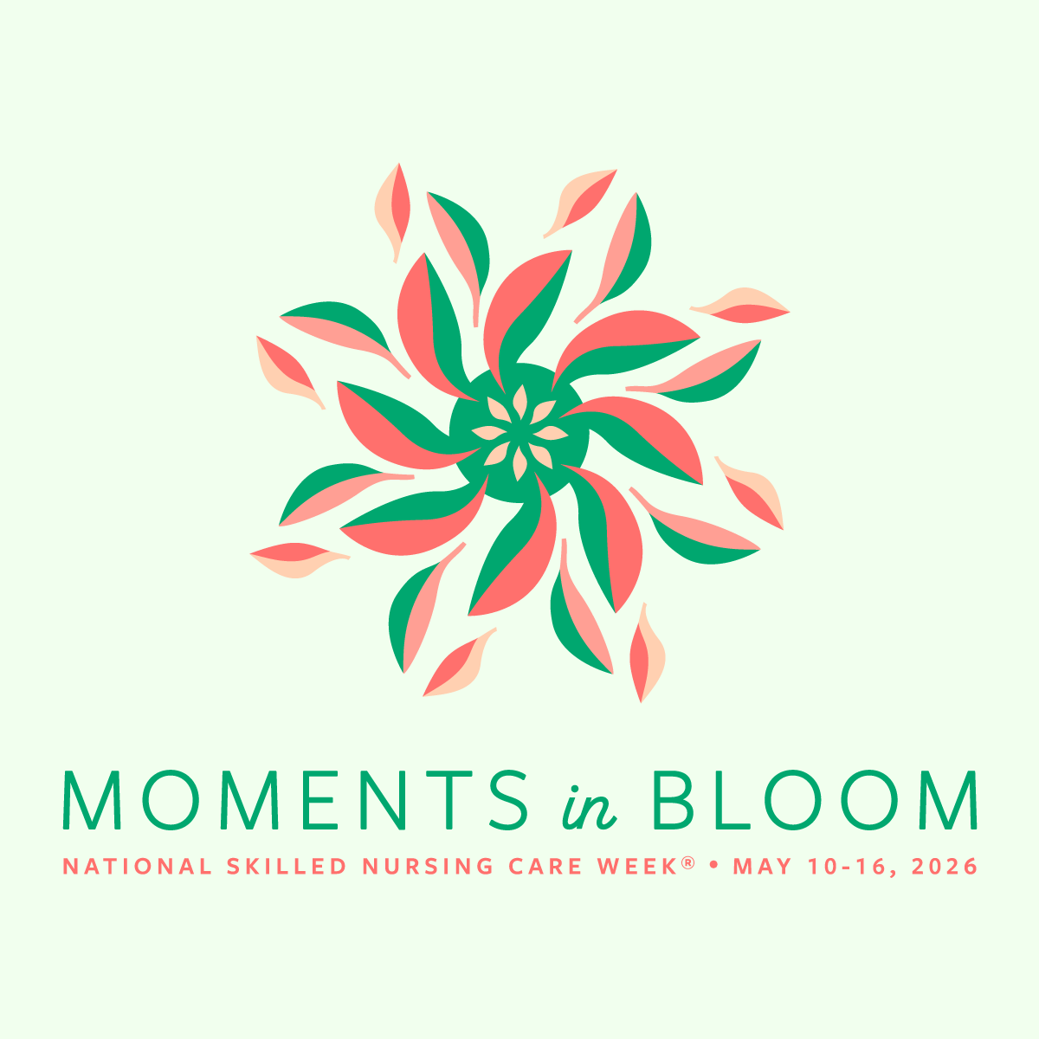 |   11  9:30 Morning Greetings/Coffee Cart  10:15 Short Stories w/Tom  10:30 Chair Aerobics  1:00 Elvis Music (DR)  2:00 Casino Day! Big Money Wheel and Roulette   |  | 12  9:30 Morning Greetings/Coffee  10:30 Food Committee Meeting  1:00 Music Choice  2:00 Movie Dining Room  2:00 Neighborhood in Bloom: Flower Planting on the Patio    National Skilled Nursing Care Week |  | 13  9:30 Rise and Shine/Coffee Cart  10:15 Finish the Line  10:30 Sittercise  2:00 John Adisano Entertains  5:45 Bingo   | 14  9:30 Rise and Shine/Coffee Cart  10:15 Current Events  10:30 Sittercise  1:00 Soft Music  2:00 Flower Power Day: Music Bingo  5:45 Pokeno    *Flower Planting Rain Date | 15  9:30 Rise and Shine/Coffee Cart  10:15 Spring Word Game  10:30 Cardio Workout  1:00 Rock & Roll Hits!  2:00 Lickety Split: Ice Cream Sundae Bar   |  | 16  10:00 Morning Coffee  11:00 1:1 Room Visits  2:00 Bingo
17  A.M Coffee Cart  11:00 1:1 Room Visits  2:00 JP Stevens Musical Performance | 18  9:30 Morning Greetings/Coffee Cart  10:15 Pet Therapy w/Quinn  10:30 Uno Game  1:00 Afternoon Music  2:00 Patio Fun |  | 19  9:30 Morning Greetings/Coffee Cart  10:15 Today’s News  10:30 Morning Workout  1:00 Soul Music  2:00 Bingo |  | 20  9:30 Rise and Shine/Coffee Cart  10:15 Trivia  10:30 Sittercise  1:00 Religious Hymns  2:00 Rosary & Communion Services  2:15 Crafts  5:45 Bingo | 21  9:30 Rise and Shine/Coffee Cart  10:15 Hangman  10:30 Morning Workout  1:00 Country Music  2:00 Residents Choice  5:45 Pokeno | 22  9:30 Morning Greetings/Coffee Cart  10:15 Ball Toss  10:30 Move and Groove Workout  1:00 Jazz Music  2:00 Bingo |  | 23  10:00 Morning Coffee  11:00 1:1 Room Visits  2:00 Vansh on Violin
24  A.M Coffee Cart  11:00 1:1 Room Visits  2:00 JP Stevens Musical Performance  31  A.M Coffee Cart  11:00 1:1 Room Visits  2:00 Pokeno | 25  9:30 Morning Greetings/Coffee Cart  10:30 80’s Workout  2:00 St. Lukes Church Service   | 26  9:30 Morning Greetings/Coffee Cart  10:30 Pet Therapy W/Riley  1:00 Soul Music  2:00 Teddy B. from Funky Junction Band Performs |  |  | 27  9:30 Meet & Greet/Coffee Cart  10:15 Morning Stretch  10:30 Sittercise  1:00 Religious Hymns  2:00 Rosary & Communion Services  2:15 Jewelry Beads  5:45 Bingo | 28  9:30 Rise and Shine/Coffee Cart  10:15 In the News  10:30 Let’s Workout  1:15 Resident Council Meeting  2:00 Bingo  5:45 Pokeno |  | 29  9:30 Morning Greetings/Coffee Cart  10:15 Ball Toss  10:30 Move and Groove Workout  1:00 Jazz Music  2:00 Trivia on the Patio (Weather Permits) | 30  10:00 Morning Coffee  11:00 1:1 Room Visits  2:00 Vansh on Violin


