
Memory Lane Event Calendar

2026

Activities By: Ruslana Rapoport, NA Roosevelt Care Center 118 Parsonage Edison, NJ 08837

Sunday | Monday | Tuesday | Wednesday | Thursday | Friday | Saturday
-Pet Therapy as Announced  -Coffee Shop: 8:30am-3:00pm  -Business Office: M-F 10:00am-3:00pm  Weekends 10:00am-12:00pm  -Beauty Parlor - By Appointment  -1:1 Sensory and Room Daily  May Birthday Celebration: 5/21/26  Wednesdays Bingo 5:45pm N4  Thursdays Pokeno 5:45pm N4  ***All Activities Are  Subject to Change* |  |  | 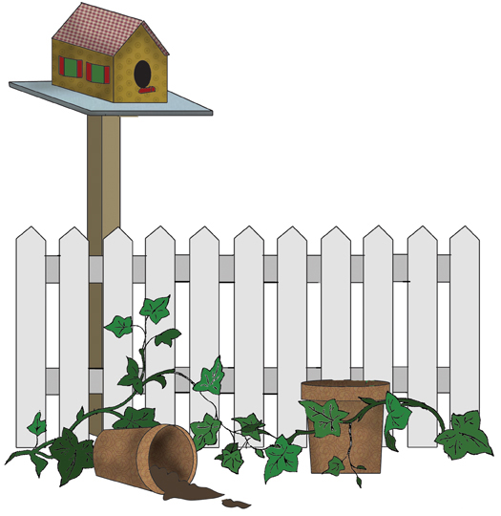 |  | 1  9:30 Coffee & Snack  10:15 Seated Exercise  10:30 Target Toss  2:00 A Day at the Races" Kentucky Derby Day (N4 LR)  2:00 Movie N4 (DR)   | 2  9:30 Coffee Cart  10:15 Parachute Game  2:00 Bingo  2:00 First Baptist Church of Metuchen N4
3  Coffee Cart  10:30 Target Toss  11:00 1:1 Visits  2:00 Music on the Alexa  2:00 Pokeno N4 | 4  9:30 Coffee & Snack  10:15 Morning Exercise  10:30 Morning Spa  2:00 Bowling  2:00 Sensory Time | 5  9:30 Coffee & Snack  10:15 Morning Stretches  10:30 Fun Facts Cinco De Mayo  2:00 Cinco De Mayo Fiesta Party N4  2:00 Sensory Time  5:45 Dice Game   | 6  9:30 Coffee & Snack  10:15 Morning Exercise  10:30 Puzzles  10:30 Pet Therapy N4  2:00 Bowling  2:00 Communion N4  2:45 Can You Picture This?  3:15 Relaxing to Music | 7  9:30 Coffee & Snack  10:15 Noodle Exercise  10:30 Short Story  2:00 Painting flowers Craft  3:00 Parachute Activity | 8  9:30 Coffee & Snack  10:15 Seated Exercise  10:30 Target Toss  11:00 Quinn Pet Therapy  2:00 Mother’s Day Social N4   |   9  9:30 Coffee Cart  10:00 Dance in your Seat  10:15 Ring Toss  2:00 First Baptist Church Special Mother Day Service N4
10  Coffee Cart  11:00 1:1 Room Visits  2:00 Tv Time  2:00 Scrapbooking N4    NSNCW Begins "Moments in Bloom | 11  9:30 Coffee & Snack  10:15 Target Toss  10:30 Morning Spa    2:00 Casino Day! Big Money Wheel and Roulette N4 | 12  9:30 Coffee & Snack  10:15 Balloon Volleyball  10:30 Food Committee Meeting N4  2:00 Neighborhood in Bloom: Flower Planting NA  5:45 Puzzle Time   | 13  9:30 Coffee & Snack  10:15 Move and Groove  10:30 Puzzles    2:00 John Adisano Entertains N4  2:45 Short Story | 14  9:30 Coffee & Snack  10:15 Seated Exercise  10:30 Ping Pong Toss  2:00 Flower Power Day: Music Bingo N4  2:45 Parachute Activity  *Flower Planting Rain Date | 15  9:30 Coffee & Snack  10:15 Seated Exercise  10:30 Target Toss  2:00 Lickety Split: Ice Cream Sundae Bar   | 16  9:30 Coffee Cart  10:15 Morning Stretch  2:00 Picture Bingo
17  Coffee Cart  11:00 1:1 Room Visits  2:00 JP Music Performance N4  2:00 Music on the Alexa | 18  9:30 Coffee & Snack  10:15 Fun Facts  10:30 Manicure Monday  2:00 Sensory Time  2:00 Bowling | 19  9:30 Coffee & Snack  10:15 Target Toss  10:30 Ping Pong toss  2:00 Making Raisin Bundt Cake  5:45 Patriotic Sing Along  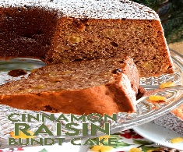 | 20  9:30 Coffee & Snack  10:15 Ball Toss  10:30 Seated exercise  2:00 Communion & Rosary Service N4  2:00 Bowling  2:45 Matching Game | 21  9:30 Coffee & Snacks  10:15 Target Toss  10:30 Sing Along to Oldies Songs  2:00 Flower Bingo  3:15 Parachute Activity  May Birthdays | 22  9:30 Coffee & Snack  10:15 Bird Matching Game  10:30 Horseshoe yard Game  2:00 Number Bingo  3:00 Picture Discussion | 23  9:30 Coffee Cart  10:15 Puzzles  2:00 Horse Racing  3:00 Easy Listening
24  Coffee Cart  11:00 1:1 Visits  2:00 Favorite Sitcoms  2:00 JP Stevens Music Performance N4 | 25  9:30 Coffee & Snack  10:15 Sit and Be Fit  2:00 St. Lukes Church Service N4  2:00 Sensory Time | 26  9:30 Coffee & Snack  10:15 True or False trivia  10:30 Puzzles  2:00 Entertainment: Teddy B!  5:45 Puzzle Time | 27  9:30 Coffee & Snack  10:15 Ball Toss  10:30 Seated exercise  2:00 Rosary and Communion Service N4  2:00 Bowling  2:45 Matching Game | 28  9:30 Coffee & Snacks  10:15 Target Toss  10:30 Sing Along to Oldies Songs  1:15 Resident Council Meeting N4  2:00 Making Devil Cookies | 29  9:30 Coffee & Snack  10:15 Ballon Toss  10:30 Short Story  2:00 Cliches  3:00 Picture Discussion | 30  9:30 Coffee Cart  10:15 Puzzles  2:00 Coloring Activity  3:00 Easy Listening
31  Coffee Cart  11:00 1:1 visit  2:00 Relaxing to Oldies Music  2:00 Pokeno N4 |  |  |  | 

