 Activities By: Kelly Inouye-Kwaak RT Unit: N3 Roosevelt Care Center 118 Parsonage Road Edison, NJ 08837
May 2026

Sunday | Monday | Tuesday | Wednesday |  | Thursday | Friday | Saturday
Pet Therapy as Announced  Coffee Shop: 8:30am-3:00pm  Business Office: M-F 10:00am-3:00pm  Weekends 10:00am-12:00pm  Beauty Parlor - By Appointment  1:1 Sensory and Room Daily  May Birthday Celebration: 5/21/26  Wednesdays Bingo 5:45pm N4  Thursdays Pokeno 5:45pm N4  Activities are Subject to Change** |  |  |  |  |  | 1  9:30 Morning Brew  10:30 Fancy Friday Nails  2:00 “A Day at the Races”-Kentucky Derby N4  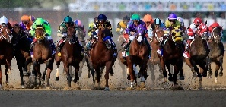 | 2  AM Coffee Cart  11:00 1:1 Visits  2:00 First Baptist Church of Metuchen N4
3  AM Coffee Cart  11:00 1:1 Visits  2:00 POKENO N4 | 4  9:30 Morning Brew  10:30 Uno    10:30 “Between the Lines” Book Club N2  2:00 The Great Outdoors (Patio) | 5  9:30 Morning Brew  10:30 Mighty Minds  2:00 Cinco De Mayo Fiesta Party- N4   | 6  9:30 Morning Brew  10:30 Dominoes  10:30 Pet Therapy w. Riley N4  2:00 Rosary and Communion N4  2:00 Patio Time  5:45 For Fun Bingo N4 |  | 7  9:30 Morning Brew  10:30 Splash of Color  2:00 BINGO    5:45 POKENO N4 | 8  9:30 Morning Brew  10:30 Left, Right, Center  2:00 Celebrating Our Moms N4 | 9  AM Coffee Cart  11:00 1:1 Visits  2:00 First Baptist Church of Metuchen Mothers’ Day Service N4
10  AM Coffee Cart  11:00 1:1 Visits  2:00 Creating Memories w/Mom N4-Scrapbooking   | 11  9:30 Morning Brew  10:30 Hangman  10:30 “Between the Lines” Book Club N2  2:00 Casino Day N4   | 12  9:30 Morning Brew  10:30 Puzzle Challenge  10:30 Food Committee Mtg N4  2:00 Neighborhood in Bloom: Planting on the Patio   | 13  9:30 Morning Brew 10:30 Let’s Roll the Dice  2:00 Rosary and Communion N4  2:00 John Adisano Entertains N4  5:45 For Fun Bingo N4   |  | 14  9:30 Morning Brew  10:30 Flower Power Crafts  2:00 Flower Power Day: Music Bingo N4  5:45 POKENO N4  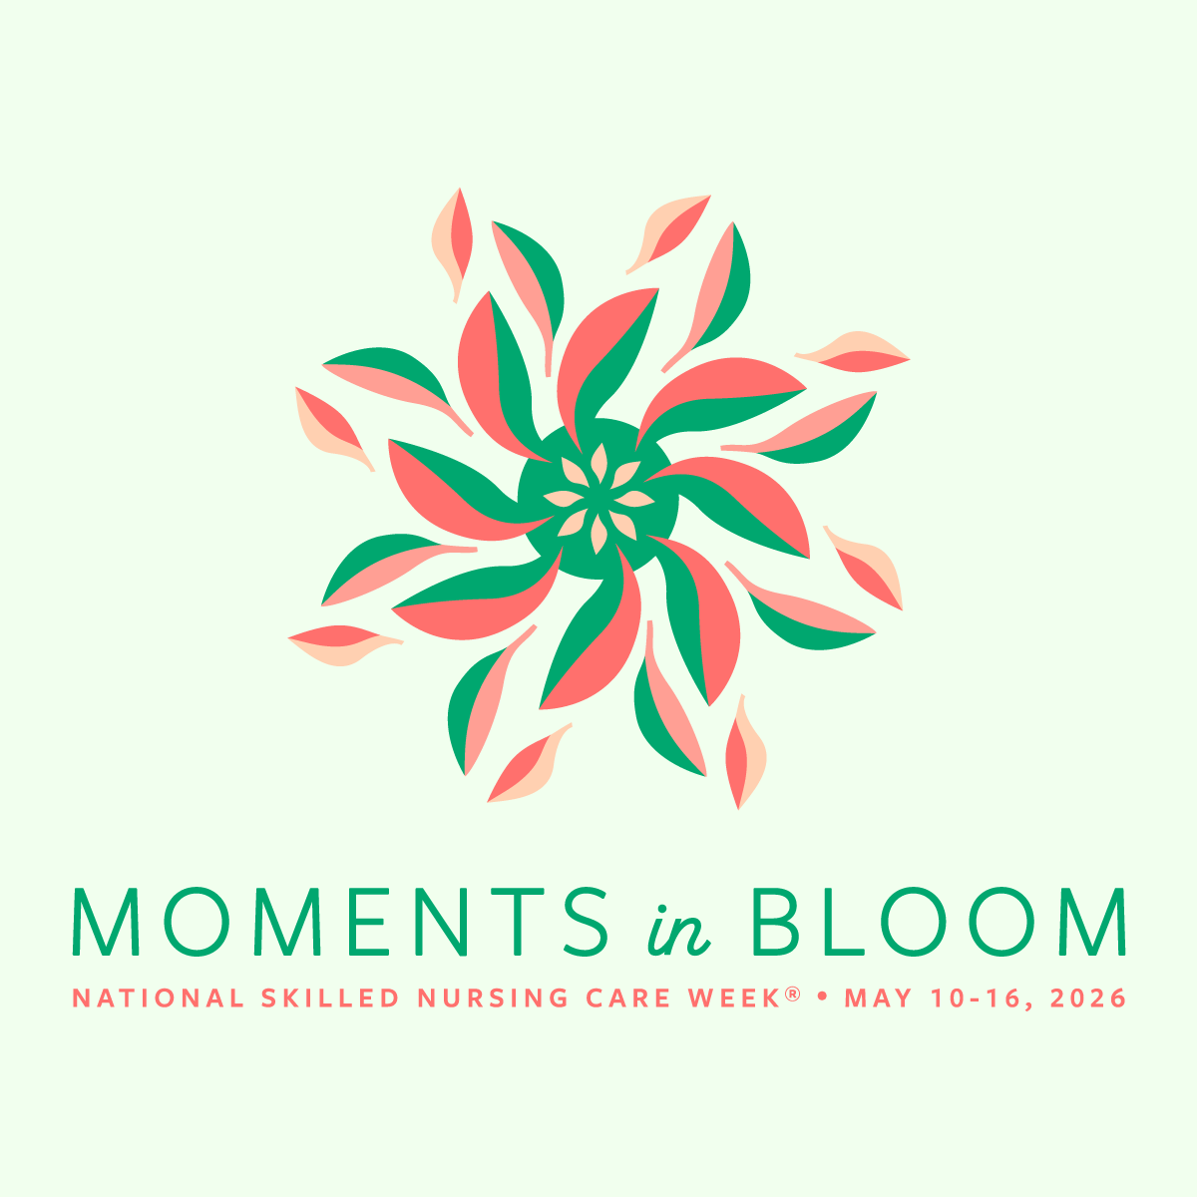 | 15  9:30 Morning Brew  10:30 Friday Manicures  2:00 Lickety Spilt: Ice Cream Sundae Bar N4   | 16  AM Coffee Cart  11:00 1:1 Visits  2:00 BINGO N4
17  AM Coffee Cart  11:00 1:1 Visits  2:00 JP Stevens Musical Performance N4 | 18  9:30 Morning Brew  10:30 Beads Galore  10:45 Pet Therapy w/Quinn    10:30 “Between the Lines” Book Club N2  2:00 Backyard Games on the Patio | 19  9:30 Morning Brew  10:30 Battle of the Brains    2:00 BINGO | 20  9:30 Morning Brew  10:30 Residents’ Choice  2:00 Rosary and Communion N4  2:00 The Great Outdoors  5:45 BINGO N4 |  | 21  9:30 Morning Brew  10:30 Dominoes    2:00 Patriotic Crafts  5:45 Pokeno N4 | 22  9:30 Morning Brew  10:30 Patriotic Sing-a-long  2:00 Bingo N4  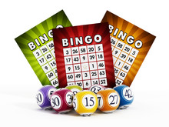 | 23  AM Coffee Cart  11:00 1:1 Visits  2:00 Vansh on The Violin N4  
24  AM Coffee Cart  11:00 1:1 Visits  2:00 JP Stevens Musical Performance N4 | 25  9:30 Morning Brew  10:30 Red, White, and Blue  10:30 “Between the Lines” Book Club N2  2:00 St. Lukes Religious Services N4   | 26  9:30 Morning Brew  10:30 Board Games  10:30 Pet Therapy w/Riley N4  2:00 Teddy B From Funky Junction Band N4 | 27  9:30 Morning Brew  10:30 Craft Corner  2:00 Rosary and Communion Services N4  2:00 Making Smoothies on the Patio    5:45 BINGO N4 |  | 28  9:30 Morning Brew  10:30 Yahtzee  1:15 Resident Council Mtg N4  2:00 Bingo  5:45 Pokeno N4 | 29  9:30 Morning Brew  10:30 Morning Manicures  10:30 Pet Therapy w/Quinn  2:00 Soak up the Sun-Patio Fun   | 30 AM Coffee Cart  11:00 1:1 Visits  2:00 Vansh on the Violin N4
31  AM Coffee Cart  11:00 1:1 Room Visits  2:00 POKENO N4 | 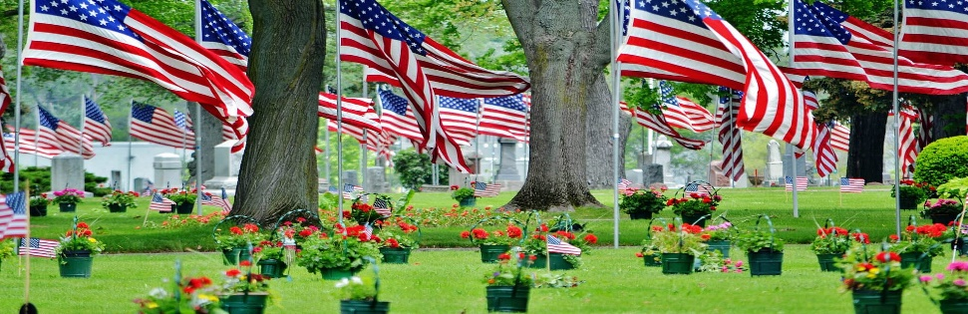 |  |  | 

