
July 2026

Activities By: Kelly Inouye-Kwaak RT Unit: N3 Roosevelt Care Center 118 Parsonage Road Edison, NJ 08837

Sunday | Monday | Tuesday | Wednesday | Thursday | Friday | Saturday
Coffee Shop: 8:30am-3:00pm  Business Office: M-F 10:00am-3:00pm  Weekends 10:00am-12:00pm  Beauty Parlor - By Appointment  1:1 Sensory and Room Daily  July Birthday Celebration: 7/23/26  Wednesdays Bingo 5:45pm N4  Thursdays Pokeno 5:45pm N4  Pet Therapy as Announced  Activities are Subject to Change* |  |  | 1  9:30 Morning Brew  10:30 Name 3  2:00 Rosary and Communion N4  2:00 The Great Outdoors  5:45 For Fun Bingo N4 | 2  9:30 Morning Brew  10:30 Uno  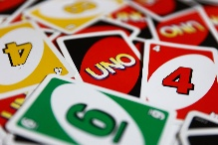  2:00 BINGO  5:45 POKENO N4 | 3  9:30 Morning Brew  10:30 Splash of Color  2:00 Red, White and Blue Popsicles | 4 AM Coffee Cart  11:00 1:1 Visits  2:00 Bingo N4  
5  AM Coffee Cart    11:00 1:1 Visits  2:00 JP Stevens Musical Performance N4 | 6  9:30 Morning Brew  10:30 Hangman  10:30 “Between the Lines” Book Club N2  10:30 Pet Therapy with Quinn N3  2:00 “Boat” Racing | 7  9:30 Morning Brew  10:30 Left, Right, Center  2:00 BINGO   | 8  9:30 Morning Brew  10:30 Puzzle Challenge  2:00 Rosary and Communion N4  2:00 The Great Outdoors  5:45 For Fun Bingo N4 | 9  9:30 Morning Brew  10:30 Dominoes  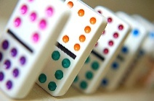  2:00 BINGO  5:45 POKENO N4 | 10  9:30 Morning Brew  10:30 Fancy Friday Nails  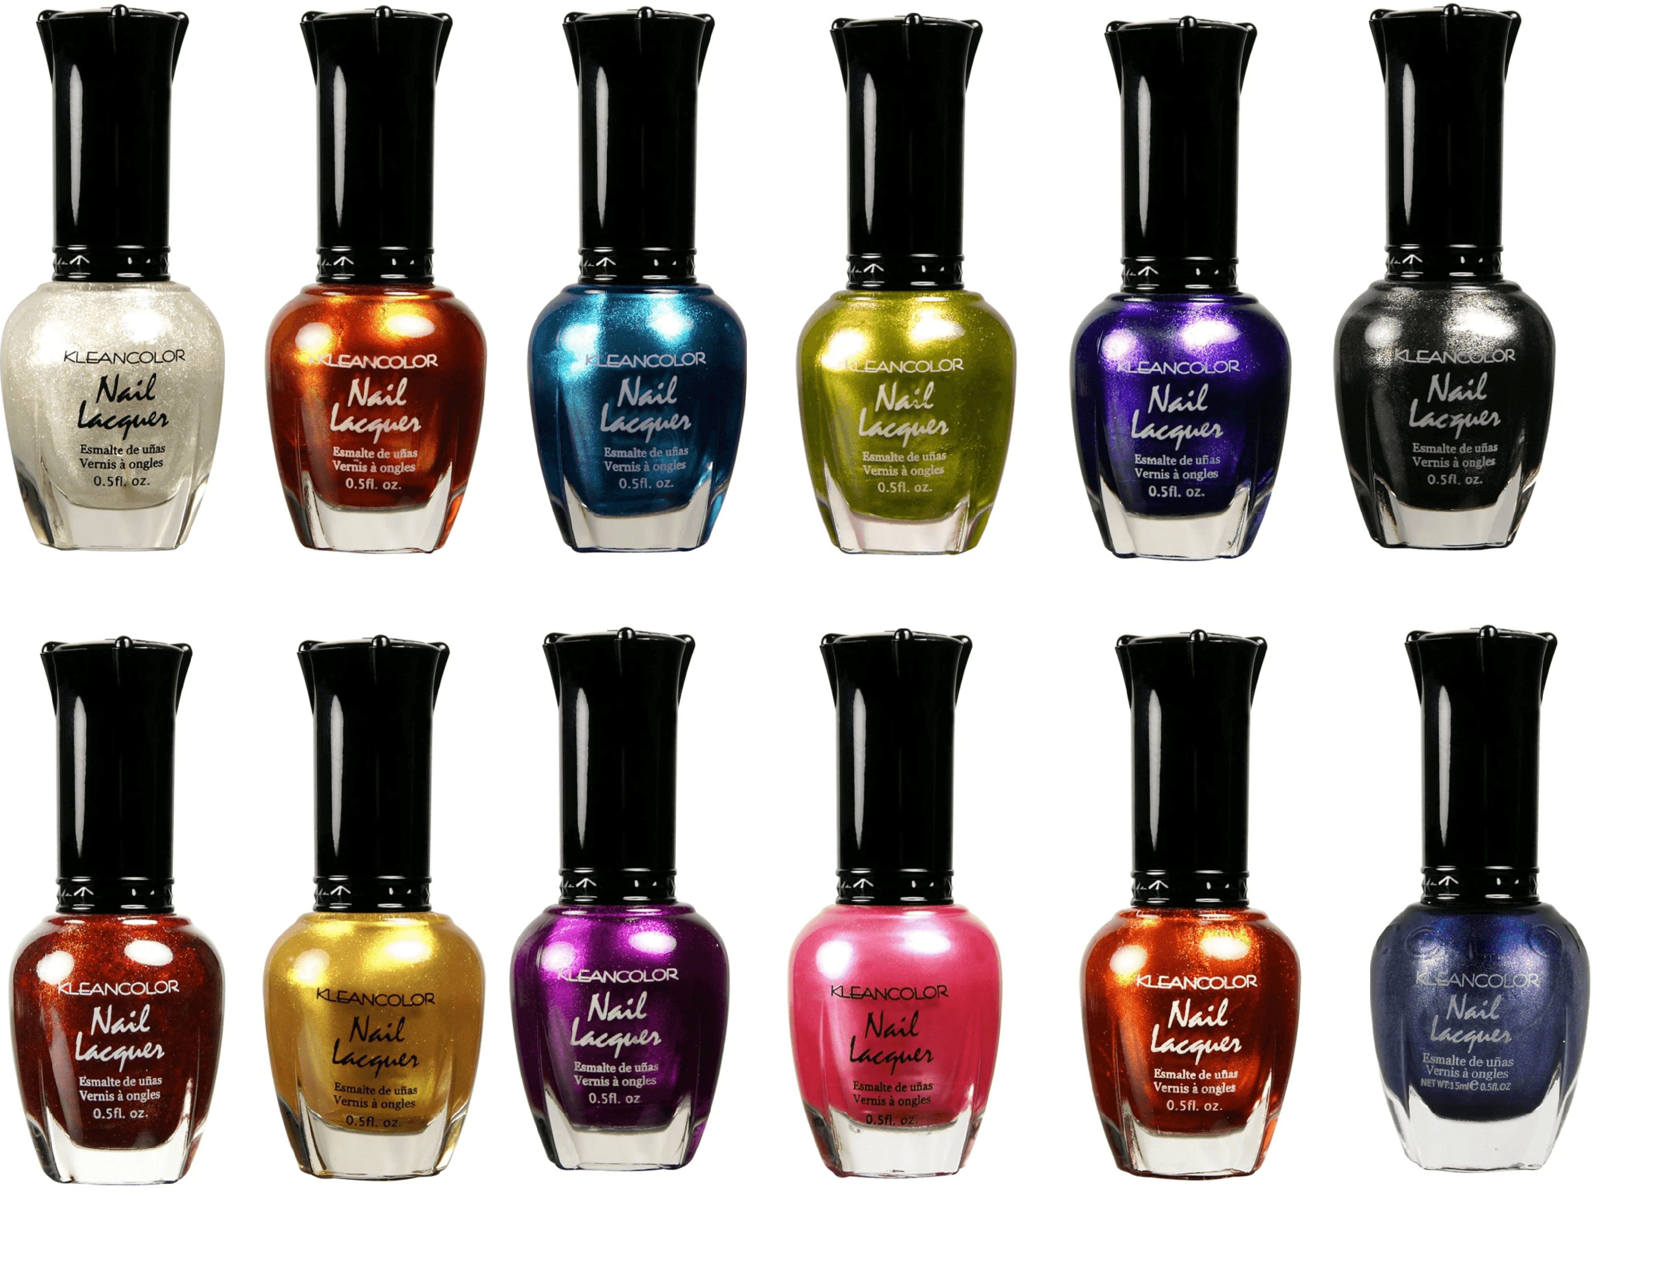  2:00 Barbara Harris Entertains N4 | 11  AM Coffee Cart  11:00 1:1 Visits  2:00 First Baptist Church of Metuchen N4
12  AM Coffee Cart  11:00 1:1 Visits  2:00 Vansh on the Violin N4 | 13  9:30 Morning Brew  10:30 Word Mining  10:30 “Between the Lines” Book Club N2  2:00 St. Lukes Religious Service N4 | 14  9:30 Morning Brew  10:30 Beads Galore  10:30 Food Committee Mtg N4  2:00 Root Beer Floats on the Patio (Weather Permitting)   | 15  9:30 Morning Brew  10:30 Finish the Line  2:00 Rosary and Communion N4  2:00 Spin Art    5:45 For Fun Bingo N4 | 16  9:30 Morning Brew  10:30 Craft Corner  2:00 BINGO  5:45 POKENO N4 | 17  9:30 Morning Brew  10:30 Soccer Keychains  2:00 Kick for the Cup World Cup Day   | 18  AM Coffee Cart  11:00 1:1 Visits  2:00 BINGO N4
19  AM Coffee Cart  11:00 1:1 Visits  2:00 POKENO N4 | 20  9:30 Morning Brew  10:30 Board Games  10:30 “Between the Lines” Book Club N2  2:00 Angela Escanillas Entertains N4 | 21  9:30 Morning Brew  10:30 Uno  10:30 Pet Therapy w. Riley N4  2:00 Splash the Staff (Patio)   | 22  9:30 Morning Brew  10:30 Squeeze the Day Crafts  2:00 Rosary and Communion N4  2:00 Lemonade Day on the Patio  5:45 BINGO N4 | 23  9:30 Morning Brew  10:30 Christmas in July Crafts  2:00 Christmas in July Music Bingo N4    5:45 Pokeno N4 | 24  9:30 Morning Brew  10:30 Fancy Friday Nails  2:00 Making Lemon Bars  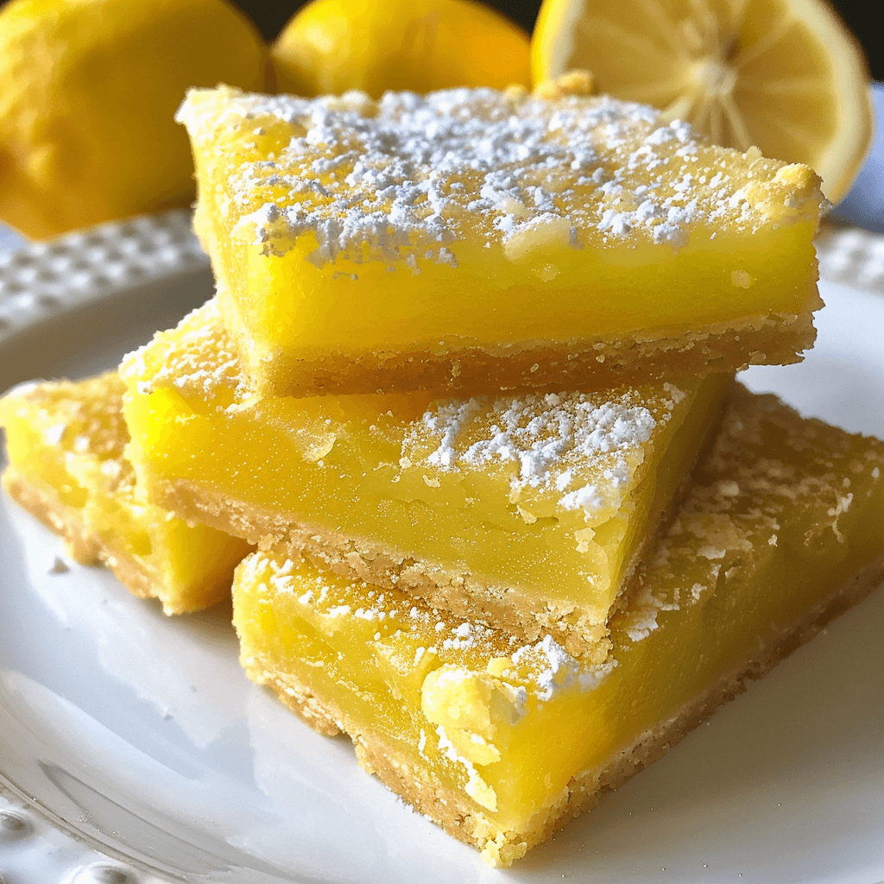 | 25  AM Coffee Cart  11:00 1:1 Visits  2:00 Bingo N4
26  AM Coffee Cart  11:00 1:1 Visits  2:00 Vansh on the Violin N4 | 27  9:30 Morning Brew  10:30 Dice Games    10:30 “Between the Lines” Book Club N2  2:00 St. Lukes Religious Services N4 | 28  9:30 Morning Brew  10:30 Banana Grams  2:00 BINGO | 29  9:30 Morning Brew  10:30 Left, Right, Center  2:00 Rosary and Communion N4  2:00 McDonald’s food ordering  (Must Sign Up)    5:45 BINGO N4 | 30  9:30 Morning Brew  10:30 Craft Corner  1:15 Resident Council Mtg N4  2:00 BINGO  5:45 Pokeno N4 | 31  9:30 Morning Brew  10:30 Seashell Jewelry  10:30 Pet Therapy with Quinn    2:00 Outdoor Games
 |  |  | 

