 Activities By: Kelly Inouye-Kwaak RT Unit: N3 Roosevelt Care Center 118 Parsonage Road Edison, NJ 08837
2026

Sunday | Monday | Tuesday | Wednesday |  | Thursday |  | Friday |  | Saturday
Coffee Shop: 8:30am-3:00pm  Business Office: M-F 10:00am-3:00pm  Weekends 10:00am-12:00pm  Beauty Parlor - By Appointment  1:1 Sensory and Room Daily  August Birthday Celebration: 8/20/26  Wednesdays Bingo 5:45pm N4  Thursdays Pokeno 5:45pm N4  Pet Therapy as Announced  Activities are Subject to Change* |  |  |  |  | 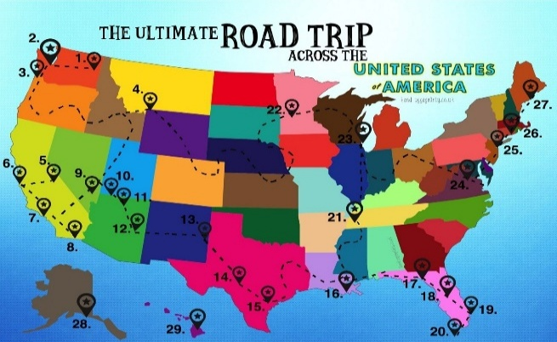 |  |  |  | 1 AM Coffee Cart  11:00 1:1 Visits  2:00 First Baptist Church of Metuchen N4
2  AM Coffee Cart    11:00 1:1 Visits  2:00 JP Stevens N4 | 3  9:30 Morning Brew  10:30 Hangman  10:30 “Between the Lines” Book Club N2  2:00 Joe Grillo Entertains N4 | 4  9:30 Morning Brew  10:30 Left, Right, Center  2:00 BINGO   | 5  9:30 Morning Brew  10:30 Hawaiian Leis  2:00 Rosary and Communion N4  2:00 Hawaiian Day  Mocktails on the Patio  (Weather Permitting)  5:45 For Fun Bingo N4 |  | 6  9:30 Morning Brew  10:30 Dominoes    2:00 Splash the Staff: Water Balloons *Patio  5:45 POKENO N4 |  | 7  9:30 Morning Brew  10:30 Fancy Friday Nails  2:00 Sandcastle Day  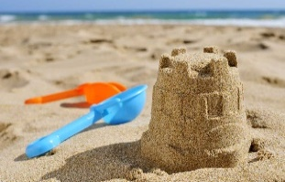  3:00 Outdoors on the Patio |  | 8  AM Coffee Cart  11:00 1:1 Visits  2:00 BINGO N4
9  AM Coffee Cart  11:00 1:1 Visits  2:00 JP Stevens N4 | 10  9:30 Morning Brew  10:30 Blueberry Art  10:30 “Between the Lines” Book Club N2  2:00 St. Lukes Religious Service N4  2:00 Celebrating Maine Blueberry Parfaits | 11  9:30 Morning Brew  10:30 Animal Talk  10:30 Food Committee Mtg N4  2:00 Bingo | 12  9:30 Morning Brew  10:30 Residents’ Choice  11:15 Pet Therapy w. Teddy  2:00 Rosary and Communion N4  2:00 Say it with Flowers  5:45 For Fun Bingo N4 |  | 13  9:30 Morning Brew  10:30 Crafters’ Delight  2:00 BINGO  5:45 POKENO N4  *Splash the Staff Rain Date* 2pm |  | 14  9:30 Morning Brew  10:30 Puzzle Challenge  2:00 Ice Cream Sundaes (Patio, weather permitting)   |  | 15  AM Coffee Cart  11:00 1:1 Visits  2:00 POKENO N4
16  AM Coffee Cart  11:00 1:1 Visits  2:00 Vansh on the Violin N4 | 17  9:30 Morning Brew  10:30 Name 3  10:30 “Between the Lines” Book Club N2  2:00 Picking Up the Pieces (puzzle art)   | 18  9:30 Morning Brew  10:30 Uno  2:00 Summerfest Patio   | 19  9:30 Morning Brew  10:30 Board Games  2:00 Rosary and Communion N4  2:00 National Potato Day    5:45 BINGO N4 |  | 20  9:30 Morning Brew  10:30 Brainstorming  2:00 BINGO  5:45 Pokeno N4 |  | 21  9:30 Morning Brew  10:30 Fancy Friday Nails  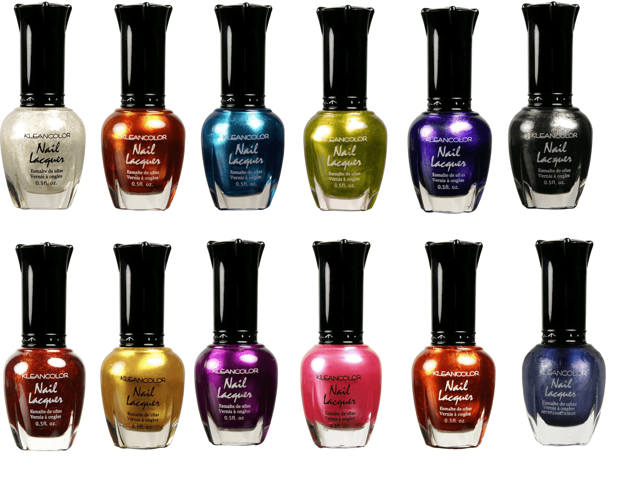  2:00 Outdoors on the Patio  3:00 Colors in Motion |  | 22  AM Coffee Cart  11:00 1:1 Visits  2:00 BINGO N4
23  AM Coffee Cart  11:00 1:1 Visits  2:00 POKENO N4 | 24  9:30 Morning Brew  10:30 Left, Right, Center  10:30 “Between the Lines” Book Club N2  2:00 St. Lukes Religious Services N4  2:00 National Waffle Day with Vermont Syrup | 25  9:30 Morning Brew  10:30 Jewelry Making  2:00 BINGO | 26  9:30 Morning Brew  10:30 Walking on Sunshine  2:00 Rosary and Communion N4  2:00 Sunflower Galore    3:00 Splash of Color  5:45 BINGO N4 |  | 27  9:30 Morning Brew  10:30 Craft Corner  1:15 Resident Council Mtg N4  2:00 BINGO  5:45 Pokeno N4 |  | 28  9:30 Morning Brew  10:30 Watermelon Crafts  2:00 Watermelon Kabobs  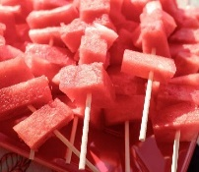  3:00 Oldies Karaoke |  | 29  AM Coffee Cart  11:00 1:1 Visits  2:00 Vansh on the Violin N4
30  AM Coffee Cart  11:00 1:1 Visits  2:00 Word Mining N4 | 31  9:30 Morning Brew  10:30 Rhode Island Lighthouses  10:30 “Between the Lines” Book Club N2  2:00 John Adisano Entertains N4 |  |  |  |  |  |  | 

