Sunday | Monday | Tuesday | Wednesday | Thursday | Friday | Saturday
-Pet Therapy as Announced  -Coffee Shop: 8:30am-3:00pm  -Business Office: M-F 10:00am-3:00pm  Weekends 10:00am-12:00pm  -Beauty Parlor - By Appointment  -1:1 Sensory and Room Daily  Birthday Celebration: 8/20/26  Wednesdays Bingo 5:45pm N4  Thursdays Pokeno 5:45pm N4  ***All Activities Are Subject to Change* |  |  | 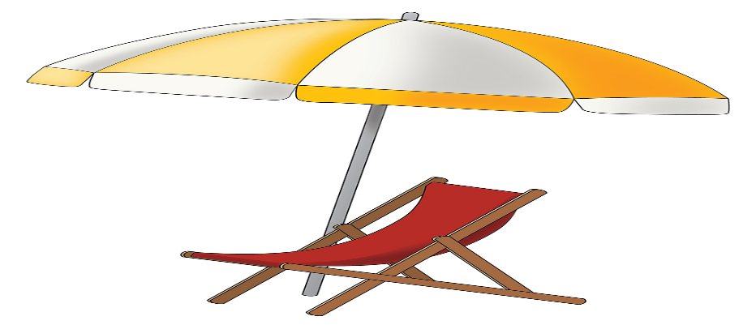 |  |  | 1  9:30 Coffee Cart  10:15 Parachute Game  2:00 First Baptist Church of Metuchen N4
2  AM Coffee Cart  11:00 1:1 Room Visits  2:00 Music on the Alexa  2:00 Summer Bingo NA  2:00 JP Stevenson Preforms N4 | 3  9:30 Coffee & Snack  10:15 Morning Exercise  10:30 Morning Spa  2:00 Joe Grillo Entertains (N4) | 4  9:30 Coffee & Snack  10:15 Morning Stretches  10:30 Mitch Miller Sing Along  2:00 Making Key Lime Pie  2:30 Key Lime Pie Discussion  2:00 Sensory Time    5:45 Dice Game | 5  9:30 Coffee & Snack  10:15 Morning Exercise  10:30 Puzzles  11:00 Pet Therapy W. Quinn  2:00 Rosary & Communion N4    3:15 Relaxing to Music | 6  9:30 Coffee & Snack  10:15 Noodle Exercise  10:30 Short Story  2:00 Splash the Staff: Water balloons Patio*  2:00 Sensory Time | 7  9:30 Coffee & Snack  10:15 Seated Exercise  10:30 Target Toss  2:00 Painting Seashells  2:45 Beach Trip Reminiscence  3:00 Parachute Activity   |   8  9:30 Coffee Cart  10:00 Dance in your Seat  10:15 Ring Toss  2:00 Paining with Watercolors
9  Coffee Cart  11:00 1:1 Room Visits  2:00 Tv Time  2:00 JP Stevens Performs N4   | 10  9:30 Coffee & Snack  10:15 Target Toss  10:30 Morning Spa  2:00 St. Lukes Service  3:00 Ice Cream Truck Discussion | 11  9:30 Coffee & Snack  10:15 Balloon Volleyball  10:30 Food Committee Meeting N4  2:00 Making Coconut Cookies  3:00 Short Story Discussion  5:45 Vansh Violin NA | 12  9:30 Coffee & Snack  10:15 Move and Groove  10:30 Puzzles  11:00 Pet Therapy w. Teddy  2:00 Rosary & Communion N4  2:00 Matching Flip Flops  2:45 Short Story | 13  9:30 Coffee & Snack  10:15 Seated Exercise  10:30 Ping Pong Toss  2:00 Word Game  2:45 Ring Toss  *Splash the Staff Rain Date | 14  9:30 Coffee & Snack  10:15 Seated Exercise  10:30 Target Toss  2:00 Ice Scream Sundaes *Patio    3:00 Listening to the Golden Oldies | 15  9:30 Coffee Cart  10:15 Morning Stretch  2:00 Picture Bingo
16  Coffee Cart  11:00 1:1 Room Visits  2:00 Music on the Alexa  2:00 Vansh on the Violin N4 | 17  9:30 Coffee & Snack  10:15 Fun Facts  10:30 Manicure Monday    2:00 Sensory Time  2:00 Flamingo Races | 18  9:30 Coffee & Snack  10:15 Target Toss  10:30 Ping Pong Toss  2:00 Summer Fest    5:45 Tropical Coloring Sheets | 19  9:30 Coffee & Snack  10:15 Ball Toss  10:30 Seated exercise  2:00 Communion & Rosary Service N4  2:00 Bowling  2:45 Matching Game | 20  9:30 Coffee & Snacks  10:15 Target Toss  10:30 Puzzle Challenge  2:00 Flower Bingo    3:00 Parachute Activity | 21  9:30 Coffee & Snack  10:15 Bird Matching Game  10:30 Horseshoe yard Game  2:00 Number Bingo  3:00 Picture Discussion | 22  9:30 Coffee Cart  10:15 Puzzles  2:00 Horse Racing  3:00 Easy Listening
23  Coffee Cart  11:00 1:1 Visits  2:00 Favorite Sitcoms  2:00 Pokeno N4 | 24  9:30 Coffee & Snack  10:15 Travel to Spain  2:00 St. Lukes Church Service N4  2:00 Sensory Time  2:00 Number Dice Game  3:00 Sing Along | 25  9:30 Coffee & Snack  10:15 True or False Trivia  10:30 Travel to Hawaii  2:00 Pineapple Upside Down Cake  5:45 Vansh on the Violin NA | 26  9:30 Coffee & Snack  10:15 Ball Toss  10:30 Travel to Niagara Falls  2:00 Rosary and Communion Service N4  2:00 Bowling  2:45 Matching Game | 27  9:30 Coffee & Snacks  10:15 Remember When… Vacation  10:30 Sing Along to Oldies Songs  1:15 Resident Council Meeting N4  2:00 Sea Animal Craft  2:45 Sea Animal Discussion | 28  9:30 Coffee & Snack  10:15 Ballon Toss  10:30 Travel to Bermuda  2:00 Picture Bingo  3:00 Picture Discussion | 29  9:30 Coffee Cart  10:15 Puzzles  2:00 Coloring Activity  3:00 Easy Listening
30  Coffee Cart  11:00 1:1 visit  2:00 Relaxing to Oldies Music  2:00 Word Mining N4 | 31  9:30 Coffee & Snack  10:15 Sit and Be Fit  2:00 John Adisano Entertains |  |  | 


Activities By: Ruslana Rapoport, NA Roosevelt Care Center 118 Parsonage Edison, NJ 08837
2026

