
2026

Activities By: Rachel Forni Roosevelt Care Center 118 Parsonage Road Edison, 08837
SUNDAY | MONDAY | TUESDAY | WEDNESDAY | THURSDAY | FRIDAY | SATURDAY
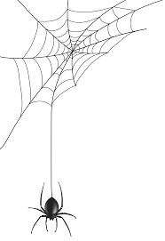  COFFEE SHOP: 8:30 - 3:00pm  BEAUTY PARLOR: BY APPOINTMENT  1:1’s WEEKLY  Business Office Weekdays 10am-3pm  Weekends 10am-12pm      ***ALL ACTIVITIES ARE SUBJECT TO CHANGE ** |  |  | 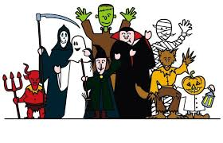 | 1  9:30 Hello!  10:00 Coffee Clutch  10:30 Move-n-Groove  11:00 Table ball  2:00 Bingo N2  3:00 Prize Time  5:45 Pokeno (N4) | 2  9:30 Good Morning  10:00 Morning Brew  10:30 Stretch It Out  11:00 Funky Fingers Friday  2:00 Teddy B. from Funky Junction Performs N4  Wear Pink Day for Breast Cancer |  |   3  A.M Coffee Cart  11:00 1:1 Room Visits  2:00 First Baptist Church of Metuchen (N4)
4  A.M Coffee Cart  11:00 1:1 Room Visits  2:00 Pokeno N4  2:00 Football Sunday w. Tom (TV) N4 | 5  9:30 How’re You?  10:00 Coffee Cart  10:30 “Between the Lines” Book Club  11:15 Balloon Toss  2:00 Fall Jewelry Making | 6  9:30 How’s it Going?  10:00 Cup O’ Joe  10:30 Group Pet therapy w/Riley N4  11:00 Name 5  2:00 Fall Fest on the Patio!  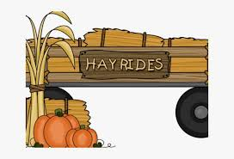 | 7  9:30 Today Is…  10:00 Java & Jive  10:30 Chair Yoga/  11:00 Dominos  2:00 Catholic Rosary & Communion N4  2:00 Noodleball  5:45 Bingo (N4) | 8  9:30 Hello!  10:00 Coffee Clutch  10:30 Jazzercise  11:00 Table ball  2:00 Bingo N2  3:00 Prize Time  5:45 Pokeno (N4)  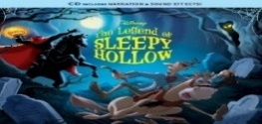  *Fall Fest Rain Date | 9  9:30 Good Morning  10:00 Morning Brew  10:30 Morning Meditation Yoga  11:00 Basketball Challenge  2:00 Frightful Friday Nails  Wear Pink Day for Breast Cancer |  |   10  A.M Coffee Cart  11:00 1:1 Room Visits  2:00 Bingo (N4)  
11  A.M Coffee Cart  11:00 1:1 Room Visits  2:00 Vansh on Violin N4   | 12  9:30 How’re You?  10:00 Coffee Cart  10:30 “Between the Lines” Book Club  11:15 Balloon Bat  2:00 Halloween Family Feud  2:00 Church Service with St. Lukes N4 | 13  9:30 How’s it Going?  10:00 Cup O’ Joe  10:30 Food Committee Meeting (N4)  11:00 Pass the Bone Game    2:00 Bingo N2 | 14  9:30 Today Is…  10:00 Java & Jive  10:30 Morning Stretch  11:00 Dominos  2:00 Creative Chefs: Pumpkin cheesecake muffins  2:00 Holy Communion & Rosary (N4)    5:45 Bingo (N4) |   15  9:30 Hello!  10:00 Coffee Clutch  10:30 Chair Dancing  11:00 Tableball  2:00 The Masked Singer! N4  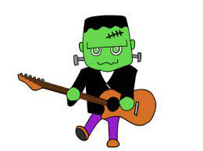  5:45 Pokeno (N4) | 16  9:30 Good Morning  10:00 Morning Brew  10:30 Move It!  11:00 Fancy Fingers Friday  2:00 Pumpkin Craft  Wear Pink Day for Breast Cancer |  | 17  A.M Coffee Cart  11:00 1:1 Room Visits  2:00 JP Stevens Music Performance (N4)
18  A.M Coffee Cart  11:00 1:1 Room Visits  2:00 Bingo N4  2:00 Football Sunday w. Tom (TV) N4  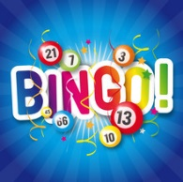 | 19  9:30 Boo to You!  10:00 Coffin & Cookies  10:30 “Between the Lines” Book Club  11:15 Balloon Toss  2:00 Olive Garden Food Ordering N4 *Must Sign Up   | 20  9:30 Fangtastic Morning  10:00 Coffin Break  10:30 Move it!  11:00 Ghost Stories  2:00 Bingo N2  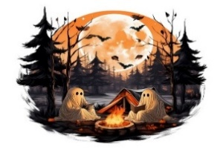 | 21  9:30 Boo-tiful Morning  10:00 Witch’s Brew  10:30 Chair Yoga  11:00 Pet Therapy with Quinn  11:15 Dominos  2:00 Let’s Make Cherry Turnovers!  2:00 Holy Communion and Rosary (N4)  5:45 Bingo (N4) | 22  9:30 Ghoul Morning  10:00 Coffin Clutch  10:30 Flap Like a Bat  11:00 Table Ball  2:00 Bingo N2  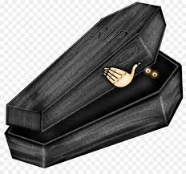  5:45 Pokeno (N4) | 23  9:30 Boo-tiful Morning  10:00 Morning Broooo  10:30 Chair Yoga  11:00 Football toss  2:00 Funky Friday Nails    Wear Pink Day for Breast Cancer |  | 24  A.M Coffee Cart  11:00 1:1 Room Visits  2:00 JP Stevens Musical Performance N4
25  A.M Coffee Cart  11:00 1:1 Room Visits  2:00 Vansh on Violin N4  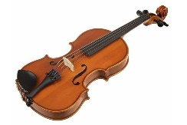 | 26  9:30 Howl Are You?  10:00 Coffine Moment  10:30 “Between the Lines” Book Club  11:15 Balloon Bat  2:00 Church Service with St. Lukes N4 | 27  9:30 Fangtastic Morning  10:00 Coffin Break  10:30 Pet Therapy w/Riley  11:00 Hangman  2:00 National Stuffed Animal Bingo Day! N4 | 28  9:30 Best Witches  10:00 Witch’s Brew  10:30 Groove & Ghouls  11:00 Pet Therapy w/Quinn  11:15 Dominos  2:00 Uno  2:00 Holy Communion & Rosary (N4)  5:45 Bingo (N4) | 29  9:30 Ghoul Morning  10:00 Coffin Clutch  10:30 Flap Like a Bat  11:00 Tableball  1:15 Resident Council N4  2: 00 Halloween Music Bingo N4  5:45 Pokeno (N4) | 30  9:30 Boo-tiful Morning  10:00 Morning Broooo  10:30 Phantom Flow Yoga  11:00 LCR  2:00 DJ Jeremy Halloween Costume Party N4  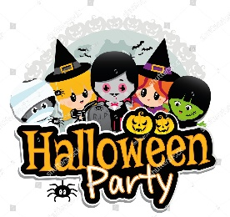 |  | 31 Halloween  Morning  Broooo Coffee  11:00 1:1 Visits  2:00 Pokeno N4  

